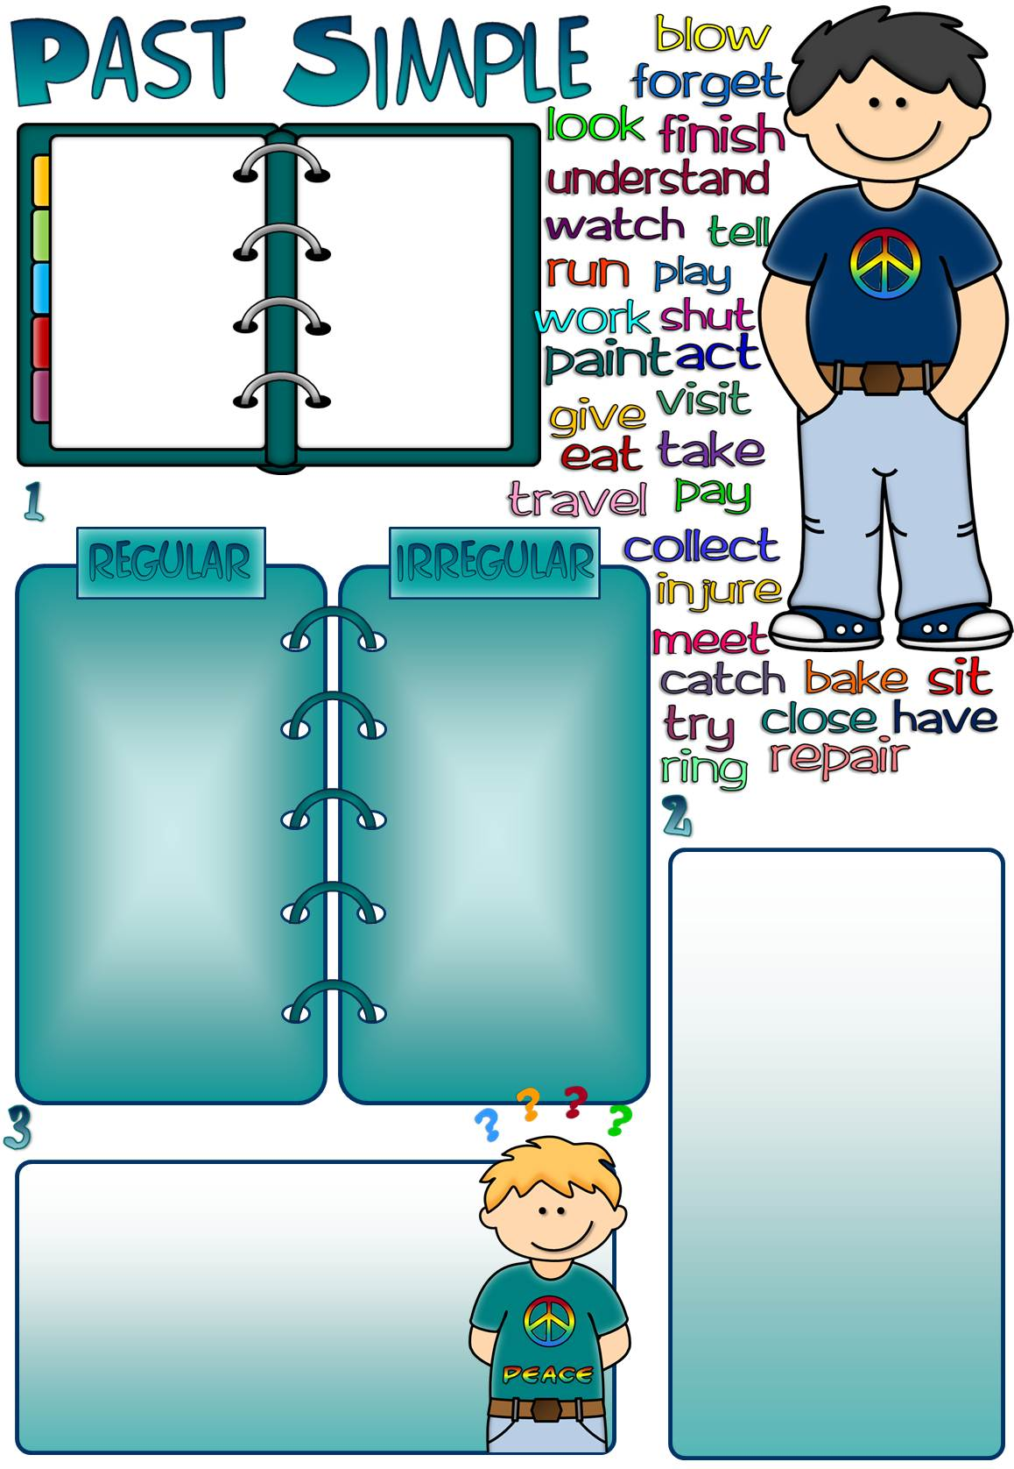

Use **Past Simple** to talk about:

* an action that happened at a definite time in

the past

I **was** hungry after school yesterday.

We **bought** a new computer last week.

Carol **stayed** in

bed last Friday.

**Common time expressions**:

yesterday/the day before yesterday,

last week/month/year

winter/summer,

last Friday/Monday,

three hours/days/ weeks/months/years

ago,

in 2010, 1973, 1649

**Put the verbs in the past form in the correct column.**

**Put the verbs in brackets in the correct form.**

1. When I _ _ _ _ _ _ _ (be) a little girl I _ _ _ _ _ _ _ (not, drink) coffee.
2. Mr. Parker _ _ _ _ _ _ _ (come) back home an hour ago.
3. Where _ _ _ _ _ _ _ (Greg and Helen, meet) last week?
4. I _ _ _ _ _ _ _ (share) a room with my sister when we _ _ _ _ _ _ _ (be) kids.
5. Peter _ _ _ _ _ _ _ (fall) off his bike last Saturday.
6. Who _ _ _ _ _ _ _ (you, talk) to in the corridor this morning?
7. We _ _ _ _ _ _ _ (not, build) our house by ourselves.
8. Nick and Terry _ _ _ _ _ _ _ (drive) to Southampton last weekend.
9. What _ _ _ _ _ _ _ (your mum, cook) for dinner yesterday?

10. My grandparents _ _ _ _ _ _ _

(spend) their honeymoon in Italy.

11. Why _ _ _ _ _ _ _ (not, Amy, bring)

her project?

12. Dave _ _ _ _ _ _ _ (smile) at me.

13. I _ _ _ _ _ _ _ (dream) about a new

MP3 player last night.

1. Sally left the window open last night. (-)

_ _ _ _ _ _ _ _ _ _ _ _ _ _ _ _ _ _ _ _ _ _ _ _ _ _ _ _ _ _ _

1. I washed up the dishes after dinner. (?)

_ _ _ _ _ _ _ _ _ _ _ _ _ _ _ _ _ _ _ _ _ _ _ _ _ _ _ _ _ _ _

1. The kids woke up early last Saturday. (?)

_ _ _ _ _ _ _ _ _ _ _ _ _ _ _ _ _ _ _ _ _ _ _ _ _ _ _ _ _ _ _

1. We flew to Dublin last month. (-)

_ _ _ _ _ _ _ _ _ _ _ _ _ _ _ _ _ _ _ _ _ _ _ _ _ _ _ _ _ _ _

1. Robert crossed the road in a hurry. (-)

_ _ _ _ _ _ _ _ _ _ _ _ _ _ _ _ _ _ _ _ _ _ _ _ _ _ _ _ _ _ _

1. Jane and Nan ran after the dog. (?)

_ _ _ _ _ _ _ _ _ _ _ _ _ _ _ _ _ _ _ _ _ _ _ _ _ _ _ _ _ _ _

**Change the sentences into negative or interrogative.**